Assignment6
1.For each of the FAs, use the minimization algorithm to find a minimum-state FA recognizing the same language.

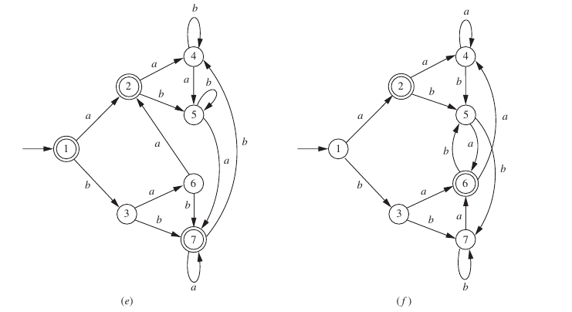
2. Each case below defines a language over {a, b}. In each case, decide whether the language can be accepted by an FA, and prove that your answer is correct.
a. The set of all strings x beginning with a nonnull string of the form ww.
b. The set of all strings x containing some nonnull substring of the form ww.
c. The set of odd-length strings with middle symbol a.
^{d The set of non-palindromes.}
e.The set of strings having the property that in every prefix, the nuof a’s and the number of b’s differ by no more than 2.
f. The set of strings in which the number of a’s and the number of b’s
^{are both divisible by 5.}
g. (Assuming that L can be accepted by an FA), Min(L) = {x ∈ L | no prefix of x other than x itself is in L}.

